A Cozy Nonprofit Coffee Shop
Written by
Jordan Ramsey
Published on
February 7, 2026
Just outside the main Branson strip, Coffee Creations isn’t trying to be trendy or flashy and that’s exactly why it works. At first glance, it’s a cozy local coffee shop serving genuinely good drinks. Spend a little time there, though, and you’ll realize it’s something more meaningful.

The story behind Coffee Creations
Greg and Linda Ordway are the owners of the ministry behind Coffee Creations. The vision for Coffee Creations goes back to the early 2000s. Long before the shop opened, Raeanne Zurn, director of Coffee Creations, knew she wanted to create a space where people with disabilities could learn practical job skills in a real-world environment—interacting with customers, handling money, following recipes, and building confidence through responsibility.
What’s striking is that it was never set out to create something symbolic or performative. She wanted something functional and honest. A place where people could work, learn, make mistakes, improve, and be seen as capable.
Today, Greg, Linda and Raeanne are still deeply involved—not just as owners, or director, but as a mentor, organizer, and advocate doing a lot of unseen work behind the scenes. Coffee Creations exists because of long-term effort, persistence, and a belief that growth happens best when people are trusted with real responsibility.

What They Serve
Coffee Creations keeps their menu approachable, but there’s more depth here than you might expect at first glance. Whether you want something simple, sweet, or fully dessert-leaning, there’s a clear lane for you.
On the coffee side, they cover all the classics well:
- Drip coffee, Americanos, lattes, and cappuccinos
- French press and pour-over options for those who want something a little more traditional
- Cold brew and iced coffee for warm Branson mornings
- Espresso shots available to add on or enjoy solo
If you’re someone who likes flavored drinks, the specialty latte lineup is where things get fun. Options like Cinnamon French Toast, Lavender Fields, Mocha Berry, Salted Mocha, and Butter Bean lean cozy and sweet without being overdone. These are comfort-forward drinks, not minimalist coffee-shop experiments.
Their frappes and smoothies are a big reason people keep coming back—especially families and non-coffee drinkers. You’ll find:
- Classic frappes like caramel, mocha, vanilla, and chocolate
- Smoothies in flavors like strawberry, mango, and wild berry
- The fan-favorite Peanut Butter Paradise Frappe, which tastes like a Reese’s in drink form and lives up to the hype
They also offer a solid non-coffee selection, including:
- Hot and iced teas (herbal, Earl Grey, oolong)
- Chai tea lattes and London Fogs
- Hot chocolate and lemonade

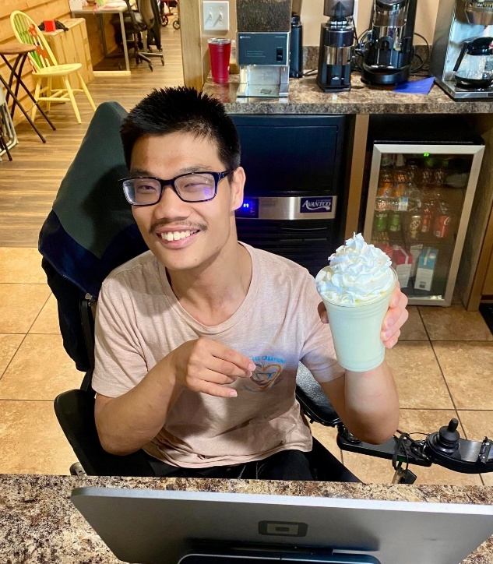

Learning through work: programs and skill-building
What sets Coffee Creations apart is not just the nonprofit label but the shop’s hands-on approach to skill-building. On certain days the café doubles as a classroom—teaching social skills, basic math through cash-handling and inventory, reading for menu comprehension, and even creative activities like painting. These structured experiences help staff members build confidence and practical competence.
The goal is straightforward and ambitious: show the community that people with disabilities are capable, skilled, and ready to contribute. Through patient training and real-world shifts, trainees learn to make drinks, interact with guests, manage a till, and be part of a team that values growth over perfection.

The vibe: what it feels like to visit
Walk into Coffee Creations and the first thing you notice is the coziness. The shop favors bright painted chairs, well-spaced tables for groups, window seating for people-watching, and two cushioned couches that invite you to linger. Colors are cheerful without being loud; music is unobtrusive and calming. The overall atmosphere is peaceful—part neighborhood living room, part community hub.
The staff’s warmth is part of the décor. Baristas will patiently explain the menu, help you make choices, and often share a laugh. Because the café emphasizes relationship-building, regulars and visitors alike leave feeling recognized and welcome.
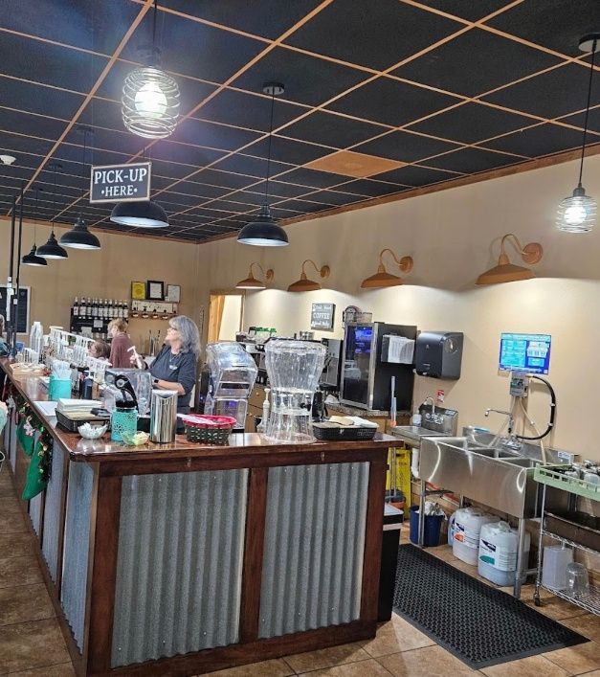

Customer Reviews
Guests often comment not only on the food and drink but on why they choose to come back. A few voices capture the sentiment well:
“Drinks are really good. The staff are so friendly, and a cute shop next to the KOA. Love supporting LOCAL!” — Melinda M.
“Cute coffee shop with indoor and outdoor seating. Very clean. Service was wonderful! They were patient as we made up our minds. They seem to focus some hiring to those with disabilities. Coffee was very good and made exactly as requested. Overall, will definitely go back.” — Debbi S.
“As someone that loves coffee, finding somewhere local that does it right can be a challenge… The staff is incredibly welcoming, and I can truly say they made my day with not just the coffee, but the staff as well.” — McKenzie Walker

Practical Info Before You Go
If you’re planning a visit, here are the basics:
- Location: 433 Animal Safari Rd, Branson, MO 65616
- Hours: Closed Sunday and Monday. Open Tuesday–Saturday, 8:00 AM–1:30 PM
- Phone: (417) 334-8507
- Kid-friendly: Yes. The space and staff are welcoming to families

